PathSimR – Technical Documentation

Contents

1 Overview 2

2 Key Features and Assumptions 2

3 Template Overview 3

3.1 Network Template Input 3

3.2 Calendar Template Input 4

4 Key Code Blocks 4

4.1 Simulation Inputs 4

4.2 Simulation Runs 5

4.2.1 Simulation Setup 5

4.2.2 External Arrivals 6

4.2.3 Backfill Loop 7

4.2.4 Service End 8

4.2.5 Delayed Departure/Transfer 9

4.2.6 Capacity Change 10

4.2.7 Replication Metric Calculation 10

4.2.8 Understanding the connection between Events & Output metrics 12

4.3 Simulation Metric Calculation 12

4.4 Simulation Outputs 13

4.4.1 Data Tables 13

4.4.2 Plots and Figures 13

4.4.3 Automated Report 13

4.5 R and Package Information 14

5 Appendix 14

5.1 Network Visualisation 14

Figures

Figure 1 - Simulation Cycle Diagram 5

Figure 2 - External Arrivals Algorithm 6

Figure 3 - Backfill Loop Algorithm 8

Figure 4 - Service End Algorithm 9

Figure 5 - Capacity Change Algorithm 10

Figure 6 - Events & Outputs Schematic 12

# Overview

PathSimR is a Discrete Event Simulation (DES) tool designed exclusively in R. Aimed at use within the healthcare sector, PathSimR uses relevant terminology and generates healthcare focussed metrics as outputs. For more information about DES, please consult the appendix.

# Key Features and Assumptions

PathSimR is capable of simulating ***patient pathways*** consisting of a number of user defined ***service points***. Each service point can take the form of any service/treatment location that has a prescribed ***capacity*** and ***service length***. In the case of a bedded ward in a hospital, this would be the number of beds and length of stay whilst in the case of a GP clinic, this would be number of GPs on shift and duration of the appointment.

Each service point along the pathway has a number of user defined parameters including:

* Calendar-dependent external ***arrival rate*** (assumed to be Poisson distributed)
* Calendar-dependent ***capacity***
* ***Service time*** that can be modelled as any parameter distribution available in R[1]
* Internal and external ***queue capacity*** (including zero and infinite)

Movement between service points and subsequently movement to an exit point is managed through a ***transition rate*** matrix which describes the proportion of patients who move between pairs of service points and/or exit points on the pathway.

PathSimR deals with both blocking after service (due to lack of downstream capacity in the pathway) and with user-specified transition delays between pairs of service points and/or service points and exit points.

The former (blocking after service) arises when there is no available capacity in an onward service point and no queue to join, which forces a patient to stay in their current location, even though they have finished active treatment there. For as long as they are blocked, no new patient can use the capacity they are occupying and will in turn be blocked up stream, have to queue, or be rejected (if queues are not permitted and they are not already occupying a service point upstream).

The latter (transition delays) are user-defined and represent either an expected delay which is not related to capacity (e.g. transport times between physical locations, or time to complete administrative tasks), or delay which may be due to capacity outside the pathway being modelled (e.g. availability of social care packages or nursing home places which the patient cannot be discharged without). They are implemented in matrices which describe pairwise delay distributions (and their parameters) between pathway locations.

The tool makes a handful of assumptions in order to simplify the modelled systems:

1. With respect to queues and service points, PathSimR assumes First Come First Served (FCFS) queue discipline
2. PathSimR assumes that once a patient joins a queue, they will not leave it until they are served at the associated service point (i.e. PathSimR does not allow reneging or baulking).
3. External arrivals into the system are assumed to be random (samples from the Poisson distribution, and hence have exponentially distributed inter-arrival times).

# Template Overview

To create a model in PathSimR, users are required to complete two input templates. These are

1. A network template, which lists all service point and exists and records information about transfer rates between service points and exits, permitted queue sizes, length of stay distributions, and pairwise fixed/specified delays/transfers between service points/discharge destinations.
2. A calendar template which lists all service points (those with modelled capacity) along with their external arrival rates and bed numbers/capacity per time unit, potentially with multiple values for each service point if the capacity/arrival rate varies cyclically over time.

Note that if using the Shiny GUI version of PathSimR, users have the option of entering the data into an input wizard, which will automatically create and validate both input templates (and create copies which can be downloaded for future use and/or modification).

## Network Template Input

The first input template used by PathSimR contains non-calendar dependent features of the model. These are (relevant areas of illustrative example template highlighted in yellow):

1. Transition Matrix
   * Proportion of patients moving from each service point (rows) to either an onward service point or exit point (columns).

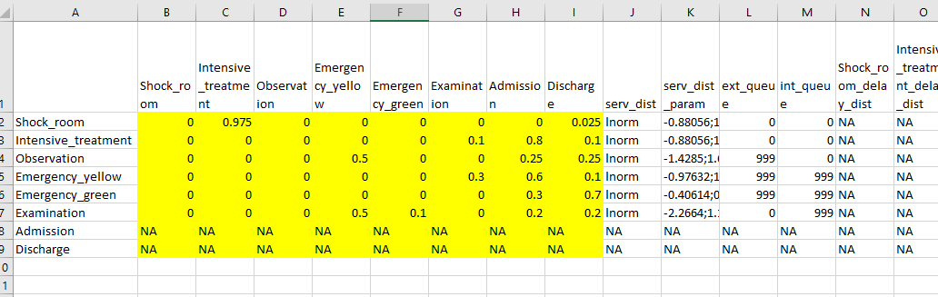

1. Service Distributions
   * Named probability distributions that are available in R and using the ‘r’ probability functions. These must be entered without the ‘r’ at the start of the name e.g. entering *exp* would result in the service times being modelled as an exponential probability distribution (using the function *rexp*).

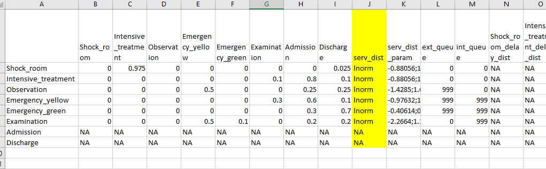

1. Service Distribution Parameters
   * For exponential, only the rate parameter needs to be supplied.
   * For all other distributions, the 2 parameters must be supplied with a semicolon separation and must be supplied in the strict order in which they are defined in R. e.g. for the gamma distribution, the first parameter must be the shape and the second must be the rate.

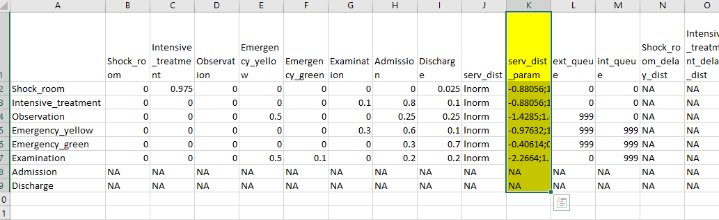

1. External Queue
   * Value for each service point setting the maximum number of external arrivals who can wait (i.e. not from any other service point).
   * Any patients who arrive when the queue is at maximum capacity are automatically rejected and ‘lost’ to the system (these losses/rejections recorded).
   * Can take any non-negative numeric value or Infinity (*Inf).*
     1. A value of zero indicates no queue is permitted.
     2. A value of *Inf* is used to indicate an unlimited queue size.

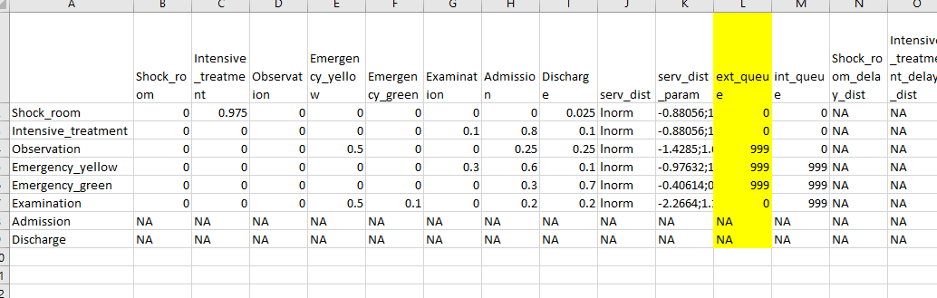

1. Internal Queue
   * Value for each service point setting the maximum number of internal arrivals (transitions) who can wait (i.e. queues between 2 service points).
   * Can take any non-negative numeric value or Infinity (*Inf).*
     1. A value of zero indicates no queue is permitted.
     2. A value of *Inf* is used to indicate an unlimited queue size.

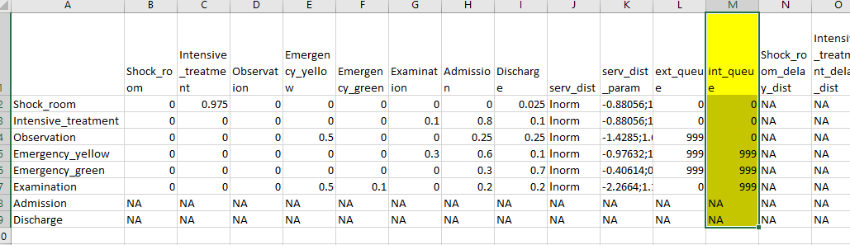

1. Transition Delay Distribution Matrix
   * Similar in format to the Transition Matrix, the TDD matrix contains the probability distributions of prescribed transition delays from service points (rows) to either an onward service point or exit (columns).
   * These follow the same entry rules as the Service Distributions.

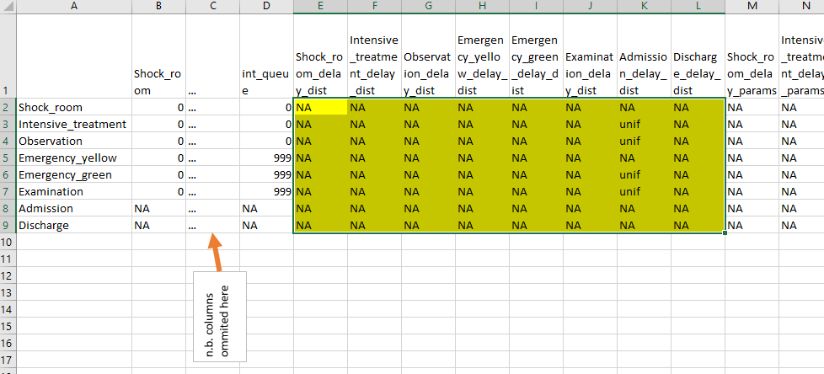

1. Transition Delay Parameter Matrix
   * Identical to above but rather than distribution names, these cells include parameters for the distributions.
   * These follow the same entry rules as the Service Distribution Parameters.

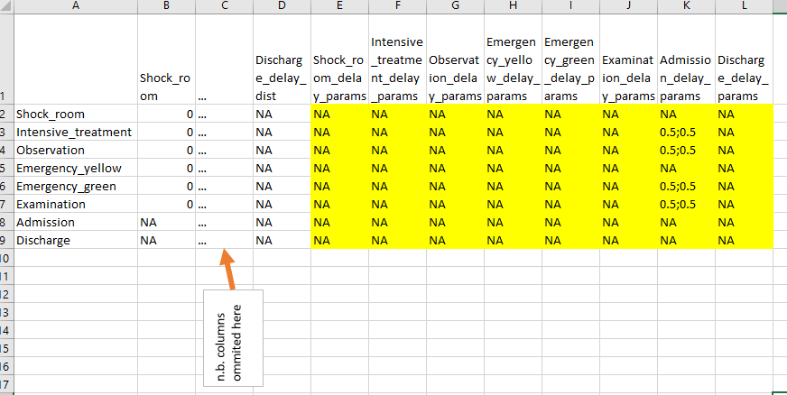

## Calendar Template Input

The second input template used by PathSimR contains calendar dependent features of the model. There are two of these features: Capacity and External Arrivals. In this template, each service point must have at least one Capacity row and at least one External Arrivals (even if the value is zero). If there is a shift in capacity or rate of arrivals, these are to be given as separate rows, with time values indicating when the transition takes place and when that value changes again. The values will cycle over the times given in the start/end columns.

The template has the following columns:

1. Metric
   * This is either *cap* (for capacity information) or *ext_arr* (for external arrival rate)
2. Node
   * This is a character string name of the service point that matches with that given in the Network Template Input
3. Start
   * The time when the capacity or external arrival rate should start
   * In the event that there is no change at a service point, a zero should be entered
4. End
   * The time when the capacity or external arrival rate should end
   * In the event that there is no change at a service point, the cell should be left blank/ NA
5. Value
   * This is the capacity or external arrival rate associated with the service point and time bracket listed.

For example, in the following calendar template there is a service point called “Intensive_treatment” which receives no external arrivals at any time (if it received a fixed number of arrivals regardless of time, the row would be the same except there would be a positive number in the “value” column instead of zero). Arrivals to this service point are hence coded by a single row with 0 as its “start” time, NA as its “end” time, and zero as its arrival rate parameter “value”:

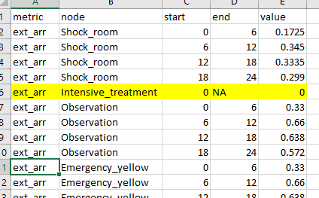

In contrast, the template also includes the service point “Observation” which does receive external arrivals, and the rate of arrivals changes of a cycle of 24 simulation time units, with a change in rate every six time units (n.b. the choice and interpretation of time units in PathSimR is made by the user, but in this case intuitively corresponds to hours in day). This is coded by four separate rows in the template, corresponding to the six hour blocks of simulation time (which rolls over back to zero once the maximum value in the cycle – in this case 24 – is reached), each with a distinct arrival rate parameter “value”:

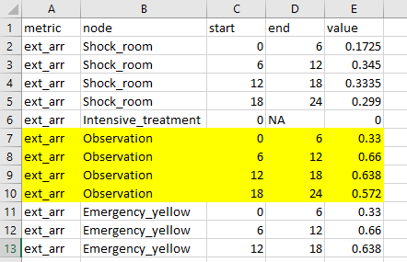

Service point capacities are treated in the same way (except the metric is “cap” and the “value” must be a positive integer which specifies the maximum number of patients who can be concurrently served in the time period given in the row).

# Key Code Blocks

PathSimR comprises two separate R scripts: a script which handles inputs, setup, runs the algorithm, and generates the output data, and a separate script which the main script calls to produce an Rmarkdown document summarising the outputs in a Word document format. (Note the Shiny GUI interface version of PathSimR comprises a single script which handles both simulation and output formatting: see the document “PathSimR – Shiny Documentation” for details).

The following section of this documentation provides a high level overview of how the algorithm works. More specific technical details are included as inline comments in the R script itself.

## Simulation Inputs

Aside from the two templates, three numeric variables must be set at the top of the script: number of replications (*reps*), length of the warm-up period (*warm_up*) and length of the simulation period (*sim_time*).

A fourth, optional, numeric input, specifies the number of computer cores to use for the simulation[2] (it is found part way though the code and is used in the *makeCluster* function).

## Simulation Runs

As DES is a stochastic method, each version (or scenario) of a modelled system should be simulated multiple times (also called replications). PathSimR has built in capability to run several replications to account for the variability in the system. Within each replication, the entire model is simulated from start to finish with a different stream of random numbers (known as the Monte Carlo method). Figure 1 shows the Simulation Cycle, colour-coded to match with all subsequent figures in the documentation. Each of the algorithm figures contain references to code scenarios that correspond to section names in the R Code Script.

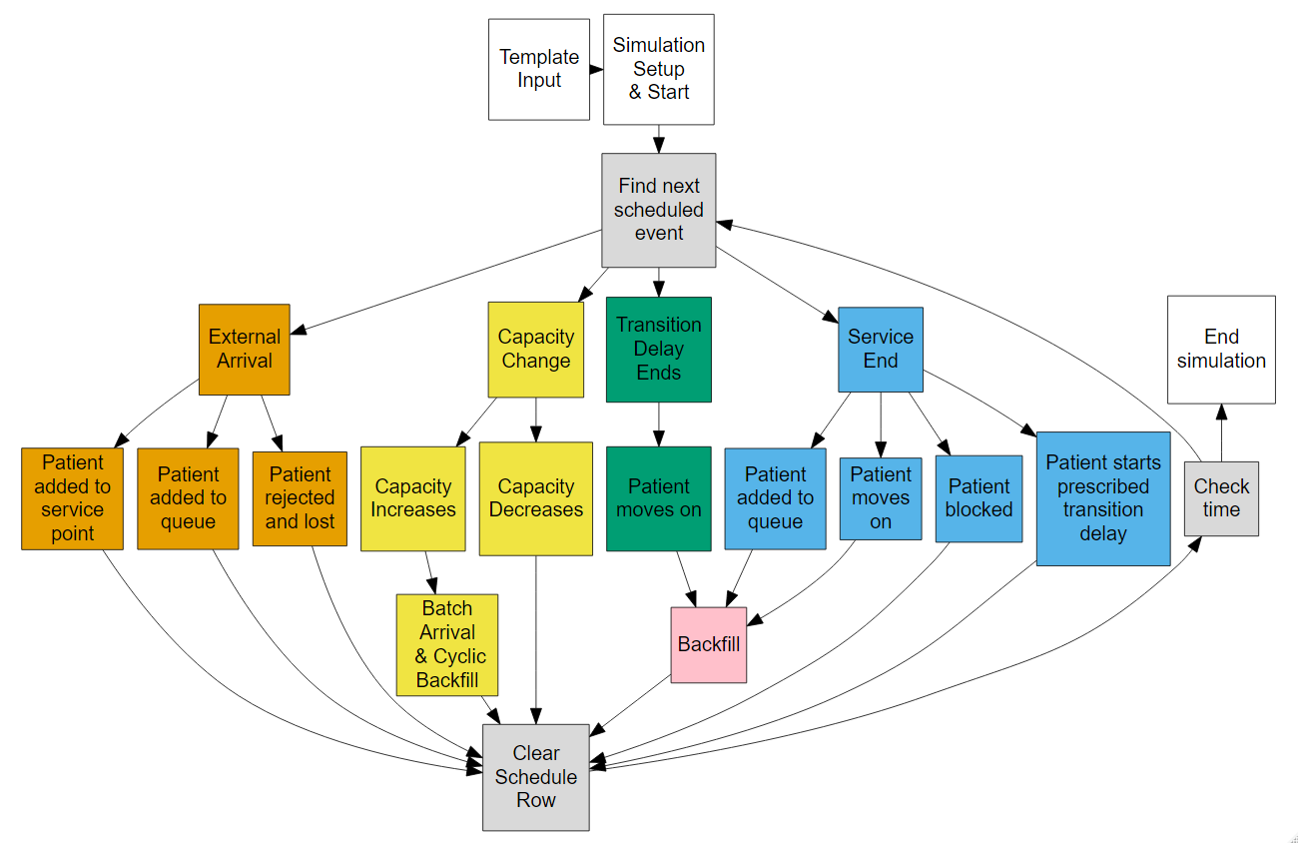

Figure 1 - Simulation Cycle Diagram

### Simulation Setup

Within each (replicated) simulation cycle, individual events are processed according to a schedule, with the different possible outcomes determined by the input parameters, the current simulation clock time, and the current state of the system (as determined by previous events).

Before each cycle can start, both input data frames (the “inputs template”, which specifies transition rates between service points and exits, service-point service distribution names and parameters, and prescribed-delay distribution names and parameters, and the “calendar template” which specifies time-dependent Poisson arrival rates and capacities for each service point) are read in and relevant data extracted.

From this, an initial *DES schedule* – which specifies when defined events (such as an arrival or completion of service at a named service point) take place – is created. At this point, it contains all (attempted) external arrivals into the system for the duration of the simulation period, and changes to capacity at service points as described in the calendar input. At this point it does not contain any other events: these will be added (and completed events deleted) as the simulation progresses. A simulation *record*, which tracks all completed events, will also be created. This will also be updated as the simulation progresses.

The inter-arrival times in the DES schedule are drawn from the (negative) exponential distribution with mean parameter equal to the mean arrival rate given for the service point in the calendar input template. As the simulation code progresses through these events, other independent events will be added and removed from the schedule including service ends and transfer delays.

The record is simply a matrix of all the events that have taken place within the simulation, both the independent events of the schedule and the dependent events of the simulation. Below is a table outlining which events are used in which table and the numeric equivalent used within the simulation cycle (to retain a numeric matrix).

|  |  |  |  |
| --- | --- | --- | --- |
| Event | Numeric Equivalent | Present in Schedule | Present in Record |
| Arrival | 1 | ✓ | ✓ |
| Service Start | 2 | ✗ | ✓ |
| Service End | 3 | ✓ | ✓ |
| Departure | 4 | ✗ | ✓ |
| Loss | 5 | ✗ | ✓ |
| Delayed Departure | 6 | ✓ | ✗ |
| Capacity Change | 7 | ✓ | ✗ |
| Transition start | 8 | ✗ | ✓ |

Table 1 - Details of events present in the schedule and record

The schedule and record use the same column headers to store data:

|  |  |  |  |  |  |
| --- | --- | --- | --- | --- | --- |
| time | event | patient | current_node | next_node | previous_node |

Table 2 - Column headers for Schedule and Record

### External Arrivals

Only external arrivals (from outside the pathway network) are scheduled, all other arrivals within the pathway (transfers from other service points) are documented in the record (but not the schedule). When evaluating an external arrival, there are 3 possible outcomes for the patient, the logic for which is outlined in Figure 2. The patient first attempts to start service in the service point (Scenario 1), subsequently attempting to enter the queue if the service point is at capacity (Scenario 2). If there is no space in either the service point or the queue, the patient is assumed lost to the system and the loss is recorded (Scenario 3).

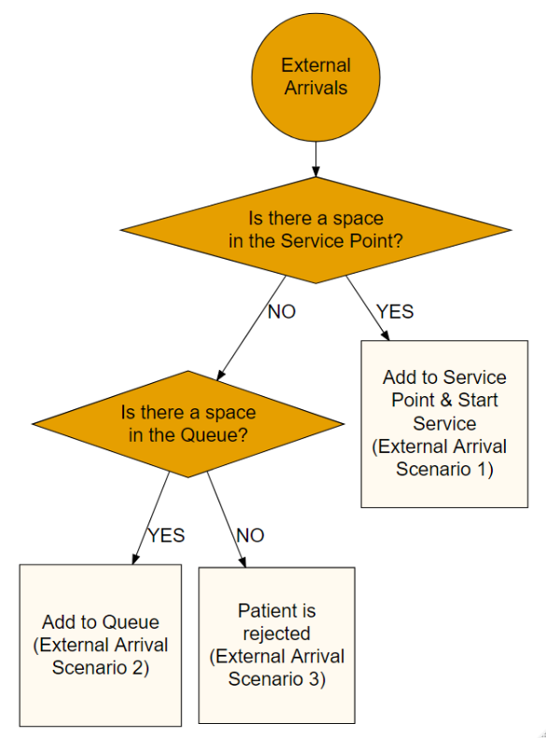

Figure 2 - External arrivals algorithm

### Backfill Loop

The Backfill Loop is the primary mechanism by which patients are moved from a waiting position, either in a queue or blocked at a service point, and moved into an active service point to start their activity. The algorithm exists as a loop because when one patient moves, the open capacity propagates upstream through the pathway so one patient finishing service and moving can have a rolling impact throughout the network. Figure 3 walks through the logic implemented here and can be split into three different streams, depending on where the patient is waiting: Blocked upstream, in the internal queue or in the external queue. PathSimR operates using a First In First Out queueing discipline, therefore the patient that has been waiting longest is the first to move when a space becomes available. If that patient is waiting in a service point (blocked) then they will be unblocked and moved. The system then finds all patients that are waiting for the newly unblocked space and if there are patients and the capacity is below the occupancy then the loop restarts with a new backfill list. If the patient is waiting in an internal queue, then there is an extra step whereby the patient is moved into the service point and then the backfill loop fills the space in the queue and subsequently the space in the previous service point in the same fashion as above. If the patient is waiting in an external queue, then the situation is much simpler as the patient simply starts service and the backfill loop ends as there are no other spaces in the system.

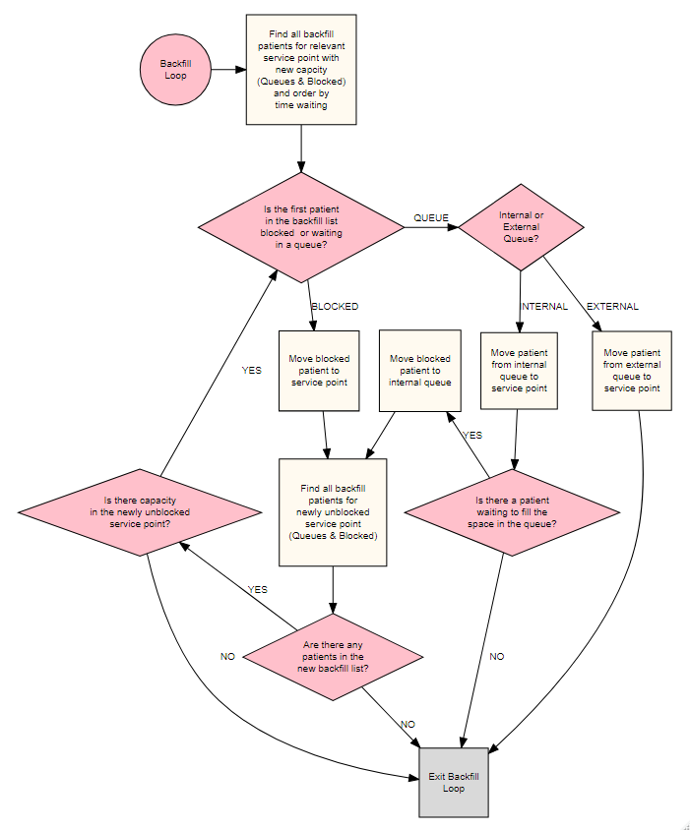

Figure 3 - Backfill loop algorithm

### Service End

Figure 4 describes the algorithm implemented and connects with Section 4.2.3, which explains the backfill loop. Where and if the patient moves are primarily dependent on space in subsequent service points and queues. If there is no space in either, then the patient becomes blocked and will continue to be until a space becomes available downstream (capacity driven delay/blocking after service) (Scenario 1). If there is no space in the onward service point but there is space in the queue, the patient will be added to the queue and the backfill loop will replace the leaving patient with any patient waiting to move in (Scenario 2a). Finally, if there is a space in the onward service point or the patient is exiting the pathway, either the patient starts a prescribed transition delay (See Section 4.2.5 and Scenario 2b) or moves onward (Scenario 2c). Transition delays are implemented in a specific way when the patient is moving between service points. At Service End, the patient will begin the delay in their current location whilst simultaneously reserving a space in their onward location for the duration of the delay. The Delayed Departure/Transition Event (Section 4.2.5) is also scheduled at this time and represents the end of the delay. In the case where the patient immediately moves, the backfill loop is again entered to fill the newly open space.

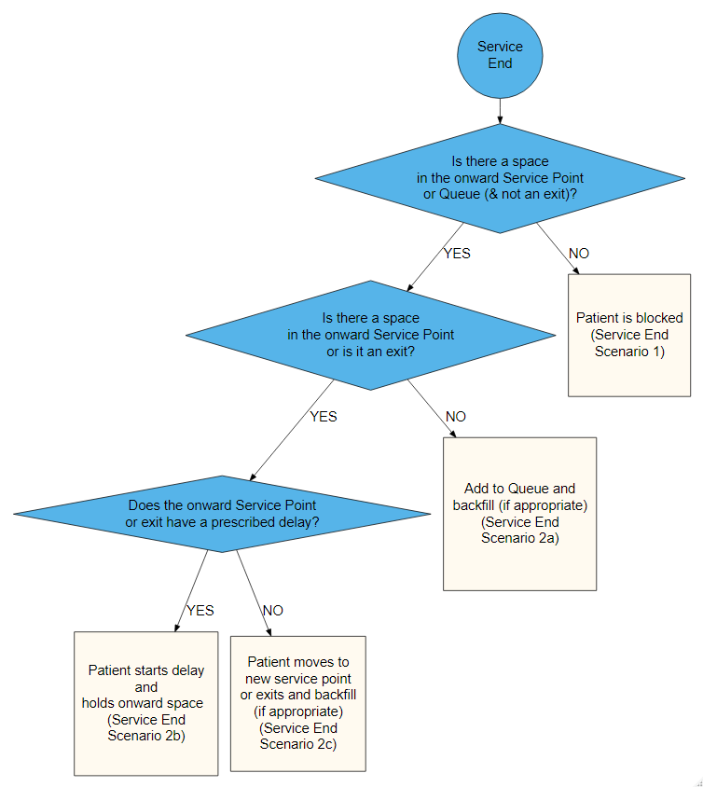

Figure 4 - Service end algorithm

### Delayed Departure/Transfer

The delayed departure/transfer event only occurs when there is a prescribed delay between 2 service points or a service point and an exit. The start of the delay is executed within the Service End (Section 4.2.3, Scenario 2b in Figure 4), which schedules the transfer end as an independent event. At the end of the transition delay, the patient moves on to their new location and if that is a service point, they occupy their reserved space and relinquish the space in their previous location.

### Capacity Change

A key feature of PathSimR is that it allows capacity of service points to change during the simulation. The creation and implementation of the calendar template is explained above (Section 3.2) but is implemented through the Capacity Change independent events in the schedule. When a Capacity Change event is executed, one of two processes may occur (See Figure 5). If the capacity has decreased, then the capacity value is simply updated for the service point and that service point will not backfill patients until the occupancy falls below the new capacity (Scenario 2). In this scenario, occupancy will slowly decrease as patients leave the Service Point and may remain above the new capacity for a large amount of time, if the patient lengths of service are significantly long enough. If the capacity has increased, a backfill loop is engaged that automatically fills all new spaces in the service point and backfill upstream (Scenario 1). This is done by finding a list of all patients who could fill the newly created capacity, moving the first along with patients upstream through backfill (see Section 4.2.3) and then moving down the list until all patients who can occupy the new capacity have been moved and started service (representing a cyclic approach to the backfill). This in effect implements batch arrivals, whereby multiple patients arrive and start service simultaneously.

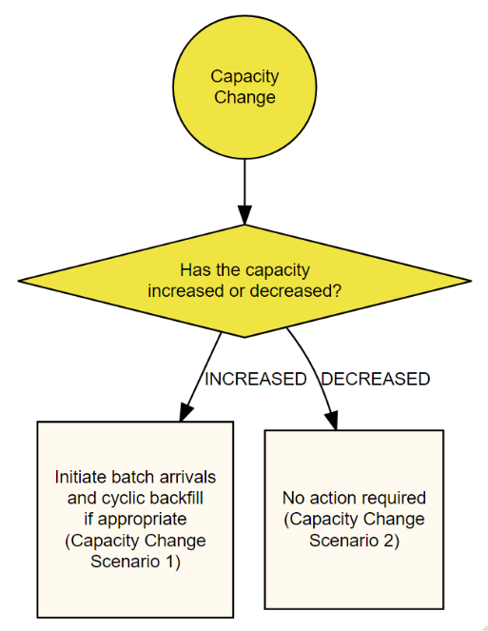

Figure 5 - Capacity Change Algorithm

### Replication Metric Calculation

For each replication, output measures and intermediate data tables are created that are subsequently averaged over all replications into whole simulation outputs. The following table outlines the key metrics created per replication, with an indication as to whether they are calculated per service point or across the entire pathway. For example, the model calculates both the average wait at each service point (based on every patient that has passed through it) and the cumulative wait experienced by patients throughout their pathway (based on every patient that has entered and exited the network). The service point based measures listed in the second half of the table are calculated for each service point separately and are used to create both tables and plots summarising the simulation results (Sections 4.3 and 4.4).

|  |  |  |  |
| --- | --- | --- | --- |
| Metric | Description and Methodology | Service point | Pathway |
| Total time in system | Time between external arrival and departure to an exit for each patient  Key values: Mean, SD, IQR, 95th Percentile | ✗ | ✓ |
| Wait | Time between arrival and service start for each patient  Key values: Mean, SD, IQR, 95th Percentile | ✓ | ✓ |
| Active Service | Time between service start and service end for each patient  Key values: Mean, SD, IQR, 95th Percentile | ✓ | ✓ |
| Time Delayed (Capacity Driven) | Time between service end and transition delay start for each patient  Key values: Mean, SD, IQR, 95th Percentile | ✓ | ✓ |
| Time Delayed (Transition) | Time between transition delay start and departure for each patient  Key values: Mean, SD, IQR, 95th Percentile | ✓ | ✓ |
| Length of Stay (LOS) | Time between service start and departure (Active Service + Time Delayed (Capacity Driven) + Time Delayed (Transition) for each patient  Key values: Mean, SD, IQR, 95th Percentile | ✓ | ✓ |
| Delay to Transfer (DTT) | Time between service end and departure for each patient  Key values: Mean, SD, IQR, 95th Percentile | ✓ | ✓ |
| Rejection Rate | Number of patients rejected from full external queues divided by the length of the simulation run | ✓ | ✓ |
| Patient Occupancy | Number of patients concurrently occupying a space (using a unit of capacity) at the service point at a given time, regardless of whether they have completed active service or are delayed. | ✓ | ✗ |
| Bed Occupancy | This includes patient occupancy as above, but also includes any beds that are currently not being physically occupied by patients (either receiving activity service or delayed), but have been reserved for patients under transition delay upstream to be transferred into (and are hence are effectively not available to other new arrivals/transfers). | ✓ | ✗ |
| Transition Delayed | Number of patients concurrently experiencing a prescribed transfer delay.   * Patients moving to downstream service points will also be reserving a space in the onward service point and thus appear in the bed occupancy metric for that unit but not the patient occupancy * Patients are included in both the occupancy and bed occupancy of the current service point | ✓ | ✗ |
| Capacity Driven Delayed | Number of patients concurrently delayed due to insufficient capacity downstream.   * These patients are included in the occupancy and the bed occupancy | ✓ | ✗ |
| Queue | Number of concurrent patients who have arrived at a service point and are yet to start the service. | ✓ | ✗ |
| % time at level (intermediate tables) | Total amount of time (for each replication) that the service point existed at a certain metric level, e.g. the queue at service point A was exactly 5 for 150 time units out of a simulation total of 1,500, therefore is there was a queue of length 5 for 10% of the simulation time. | ✓ | ✗ |
| Through time values (intermediate tables) | A sample of all the through time metrics to create uniform time series (step size manually defined) so that means of values at specific time steps can later be taken across all replications (see section 4.3 below) and used to create an “average” time series for the overall simulation, for each measure. | ✓ | ✗ |

SD – Standard Deviation; IQR – Inter-Quartile Range; 95th Percentile – Value under which 95% of the data falls

Table 3 - Replication level metrics and measures

### Understanding the connection between Events & Output metrics

The previous section outlined which measures are recorded from the simulation as outputs. Figure 6 shows how the events experienced by each patient at each Service Point translate into the outputs. The metrics in the coloured boxes and on the arrows represent patient-based outputs that all reflect an amount of time in a certain state. For example, the Length of Stay is the sum of the Active Service, Time Delayed (Capacity Driven) and Time Delayed (Transition), each of which are calculated separately for each patient.

The metrics sampled through time (Queue, Patient Occupancy, Bed Occupancy, Capacity Delayed, Transition Delayed) represent the number of patients concurrently existing in the different states (which are connected to the coloured boxes in Figure 6).

* Queue – Number of patients concurrently between Arrival & Service Start
* Patient Occupancy – Number of patients concurrently between Service Start and Departure
* Bed Occupancy – Number of patients concurrently between Service Start and Departure in the Service Point plus any bed reserved by a patient in an upstream Service Point
* Capacity Delayed – Number of patients concurrently between Service End and Transition Start
* Transition Delayed – Number of patients concurrently between Transition Start & Departure

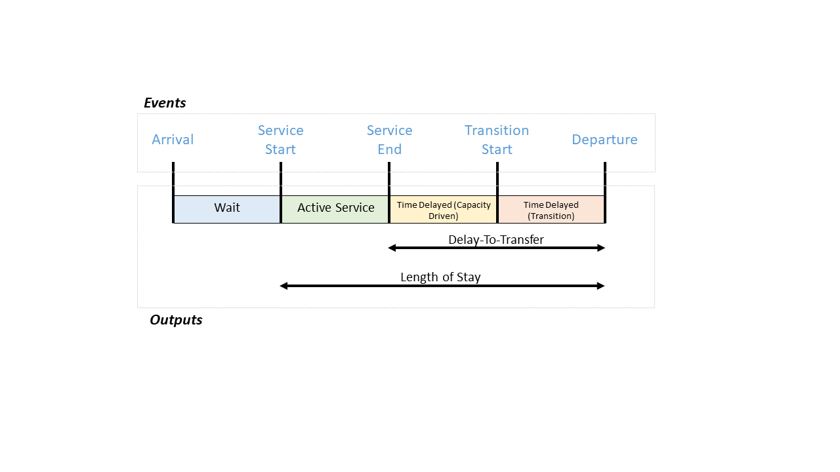

Figure - Events & Outputs Schematic

## Simulation Metric Calculation

As described above, each replication produces metrics of interest which are subsequently aggregated to give typical results across all replications. These are often means over all the replications but some measures are calculated based on all the simulation data rather than a simple aggregation.

|  |  |  |  |
| --- | --- | --- | --- |
| Metric | Description and Methodology | Service point | Pathway |
| Total time in system Summary | Average of replication level measure | ✗ | ✓ |
| Wait  Summary | Average of replication level measure | ✓ | ✓ |
| Active Service  Summary | Average of replication level measure | ✓ | ✓ |
| Time Delayed (Capacity Driven) Summary | Average of replication level measure | ✓ | ✓ |
| Time Delayed (Transition) Summary | Average of replication level measure | ✓ | ✓ |
| Length of Stay (LOS)  Summary | Average of replication level measure | ✓ | ✓ |
| Delay to Transfer (DTT)  Summary | Average of replication level measure | ✓ | ✓ |
| Rejection Rate  Summary | Average of replication level measure | ✗ | ✓ |
| % time at level (Final tables) | All the replication level tables are combined and a result is formed from the total simulation dataset | ✓ | ✗ |
| Through time values (Final tables) | Given that all the replications produce the same uniformly sampled datasets, the time series can be averaged and the percentiles of data can also be calculated. | ✓ | ✗ |
| Average Value | Using the simulation level % time at level data, an average value for each of the through time measures is created. | ✓ | ✗ |
| Percentiles | Using the simulation level % time at level data, percentiles are interpolated for each of the through time measures is created. | ✓ | ✗ |

Table 4 - Simulation level metrics and measures

## Simulation Outputs

PathSimR creates three key simulation output packs: an excel workbook containing all summary tables, a series of PDFs showing all plots and figures generated for the outputs and an automated report in Word that contains all summary tables and figures in a standardised format. The R workspace is also saved down for further manipulation.

### Data Tables

PathSimR collates all key measures into a list and then saves each entry of that list to a tab in an excel workbook. The workbook contains all the measures outlined in Section 4.3 and the tab names match the metrics listed above.

### Plots and Figures

All plots produced by PathSimR are created using the ggplot2 package which allows for maximum flexibility and manipulation of the raw data. The figures are saved down using the *ggsave* function.

### Automated Report

PathSimR comes with a separate RMarkdown file that automatically creates a report template including all figures and summary tables produced by the tool. This file can be edited separately to customise the automated report.

## R and Package Information

PathSimR has been developed using R version 3.6.0 (2019-04-26) “Planting of a Tree” and RStudio version 1.2.

In order to function correctly, the following packages are required to run the PathSimR script and UI tool. Given versions were used and the tool has not been tested with earlier/later versions of these libraries:

* shinyalert v1.0
* gridExtra v2.3
* DT v0.5
* shiny v1.3.2
* DiagrammeR v1.0.1
* knitr v1.22
* openxlsx v4.1.0.1
* data.table v1.12.2
* forcats v0.4.0
* stringr v1.4.0
* dplyr v0.8.1
* purrr v0.3.2
* readr v1.3.1
* tidyr v0.8.3
* tibble v2.1.3
* tidyverse v1.2.1
* plotly v4.9.0
* magrittr v1.5
* abind v1.4-5
* ggplot2 v3.2.0

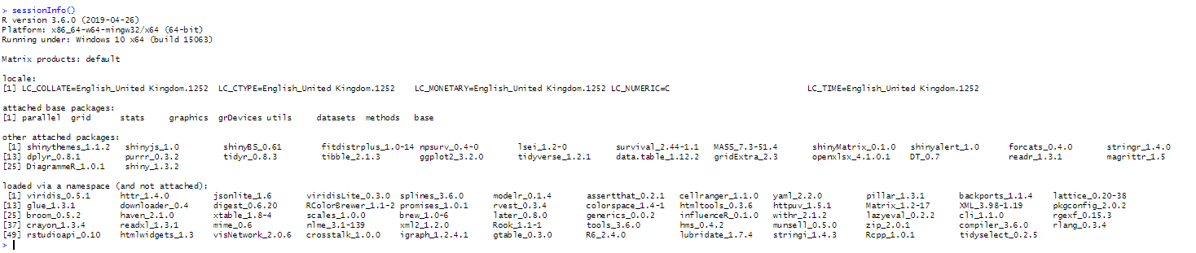

# Appendix

## Network Visualisation

PathSimR makes use of the ‘dot’ language and its implementation within the DiagrammeR package to create network visualisations. The code reads in the 2 templates and proceeds to create a service point data frame (*ndf*) that contains all the information regarding the service points and exits and the edge data frame (*edf*) that contains all the information about connections between service points. Various aesthetics are edited within the *ndf* to distinguish between service points and exits (colour and shape) and within the *edf* to highlight external arrivals and transition delays (arrow colour). Tooltips are also assigned and contain a capacity calendar for the service points and delay parameters for transition delay arrows. Overall, a html representation of the network is produced and can be called into the R viewer on successful runs of the code.

1. If entering data via the spreadsheet input template option, the name of any statistical distribution which has density and sample distributions defined in base R (e.g. dnorm(), rnorm()) can be entered into the templates. If using the input wizard in the Shiny App, the distributions available are restricted to those included in the user-input menus.
2. It is set by default to the minimum of (i) the number of replicates minus one, and (ii) the number of available computer processor cores minus one. For example, if running 1,000 replicates on a quad-core laptop, the value would be set to min(999,3)=3.